AI Assisted Coding (AIAC)
Assignment 1.2
Name: P.Thrishank
Hallticket No: 2303A52013
Batch: 31
Task 1: AI-Generated Logic Without Modularization (Factorial without Functions)
Prompt:
Write a program to calculate the factorial of a number.
Do not use any user-defined functions.
Use only loops and variables.
Take input from the user and display the result.
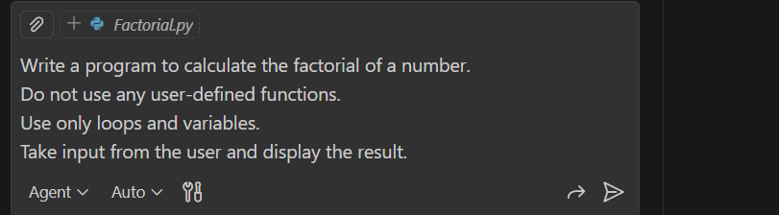
Code:
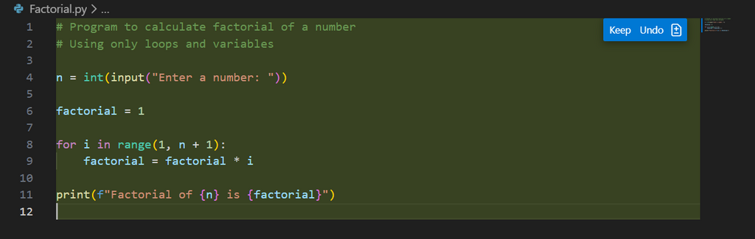

Output:
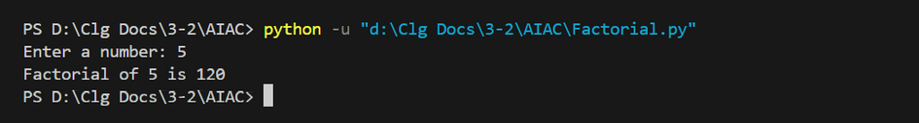
Explanation:
Copilot was very helpful for a beginner as it quickly generated correct logic based on the given prompt. It reduced the time required to write the code by suggesting a complete solution. The generated code was simple, readable, and followed basic programming best practices. Copilot also helped in avoiding syntax errors and logical mistakes. Overall, it made the coding process easier, faster, and more efficient.
Task 2: : AI Code Optimization & Cleanup (Improving Efficiency)
Prompt:
Optimize the previously generated factorial program.
Remove unnecessary variables.
Simplify the logic.
Improve readability and efficiency of the code.
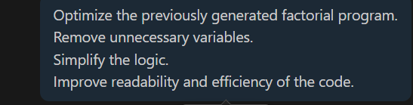
Code:
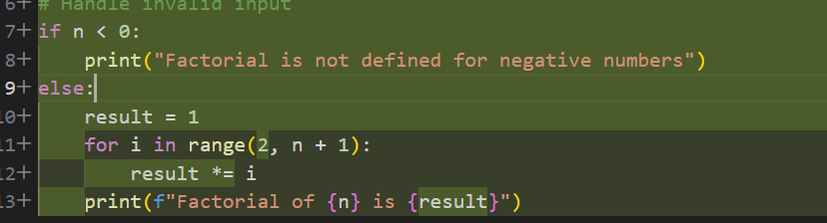

Output:
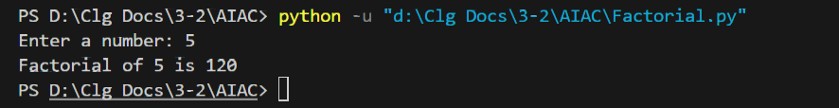

Explanation:
This optimized program first checks whether the input number is negative. If the number is less than zero, it prints a message stating that factorial is not defined for negative numbers. Otherwise, it initializes the result variable to 1 and calculates the factorial using a loop starting from 2 up to the given number. This reduces unnecessary operations and improves clarity. Finally, the result is printed in a readable format, making the code more efficient and easy to understand
Task 3: Prompt (With Functions / Modular Design)
Prompt:
Generate a factorial program using a user-defined function.
Use meaningful function and variable names.
Add inline comments explaining the logic.
Call the function from the main execution block.
Code:
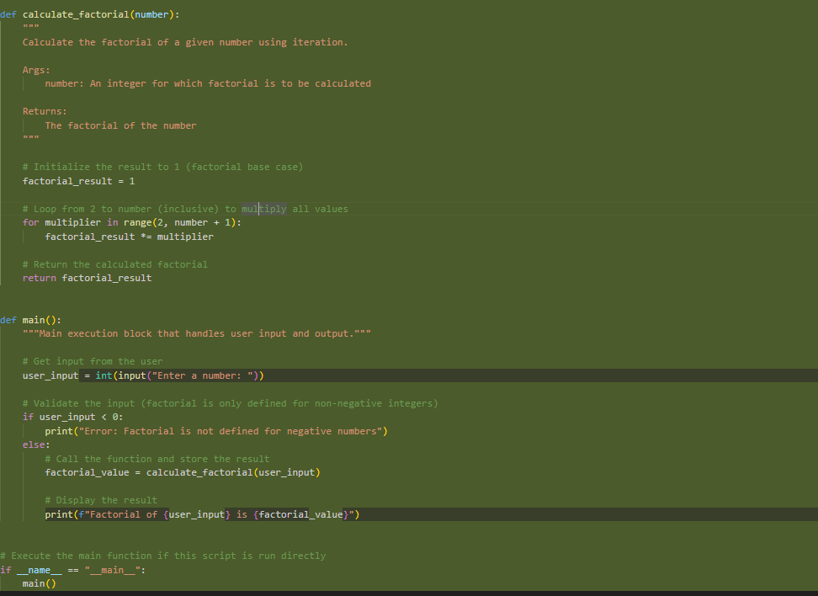
Output:
Explanation:
This program calculates the factorial of a number using a user-defined function, making the code modular and reusable. The function calculate_factorial() takes an integer as input and computes its factorial using an iterative loop. A result variable is initialized to handle the base case of factorial. The main() function is responsible for taking user input, validating whether the number is non-negative, and calling the factorial function. If a negative number is entered, an error message is displayed. Finally, the program prints the calculated factorial. Using functions improves readability, reusability, and makes the program easier to maintain and debug.
Task 4: Prompt (Comparative Analysis)
Explanation:
Aspect | Non-Function | Function-Based
Logic Clarity | Poor | Excellent
Reusability | None | High
Debugging | Difficult | Easy
Scalability | Limited | Excellent
AI Dependency | Higher | Lower
Professional Quality | Low | High

Task 5 – Prompt (Iterative vs Recursive)
Prompt 1:
Generate an iterative solution to calculate factorial using loops.
Ensure correct output for all valid inputs
Code:
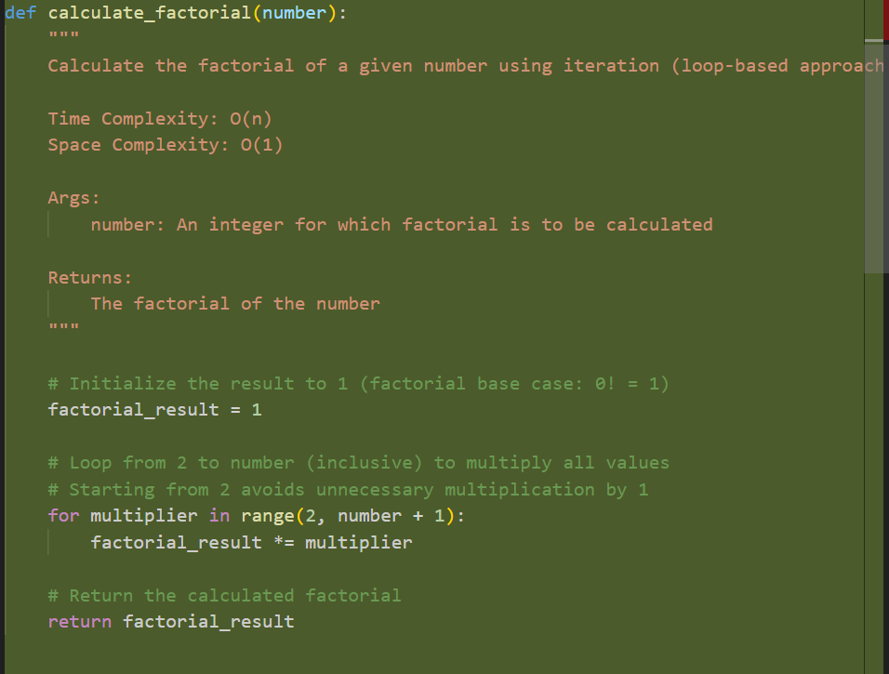
Output:

Prompt 2:
Generate a recursive solution to calculate factorial.
Include a proper base condition.
Ensure the output matches the iterative version.
Code:
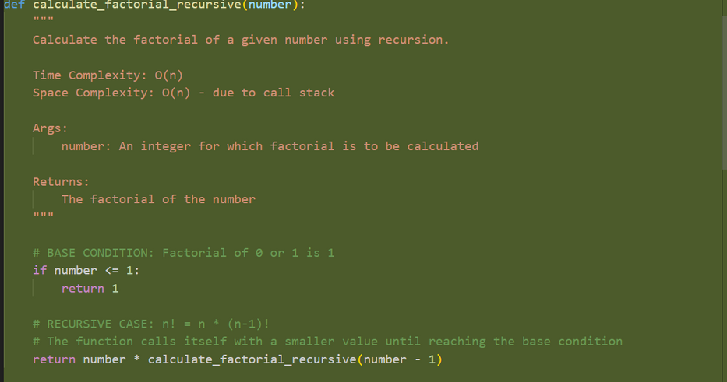
Output:
ITERATIVE VERSION EXPLANATION:
The iterative approach calculates the factorial by starting with an initial value of 1 and repeatedly multiplying it using a loop. The control flow remains within a single function and completes execution once the loop ends. This approach is simple, efficient, and easy to understand, especially for beginners.
Example: factorial(5)
Result starts at 1
Multiply by 2 → result becomes 2
Multiply by 3 → result becomes 6
Multiply by 4 → result becomes 24
Multiply by 5 → result becomes 120
Final result returned is 120
RECURSIVE VERSION EXPLANATION:
The recursive approach calculates the factorial by calling the same function with a smaller input each time. Each function call is stored on the call stack until the base condition is reached. Once the base case is met, the function returns values step by step while unwinding the stack.
Example: factorial(5)
factorial(5) calls factorial(4)
factorial(4) calls factorial(3)
factorial(3) calls factorial(2)
factorial(2) calls factorial(1)
Base condition reached → returns 1
Returns 1 × 2 = 2
Returns 2 × 3 = 6
Returns 6 × 4 = 24
Returns 24 × 5 = 120
Aspect | Iterative Approach | Recursive Approach
Readability | Easy to understand and follow, especially for beginners | Slightly harder to understand due to nested function calls
Stack Usage | Uses constant memory and does not rely on the call stack | Uses the call stack for every function call, increasing memory usage
Performance Implications | Faster and more memory-efficient | Slower for large inputs due to stack overhead
When Not Recommended | Safe and suitable for large input values | Not recommended for large inputs as it may cause stack overflow

